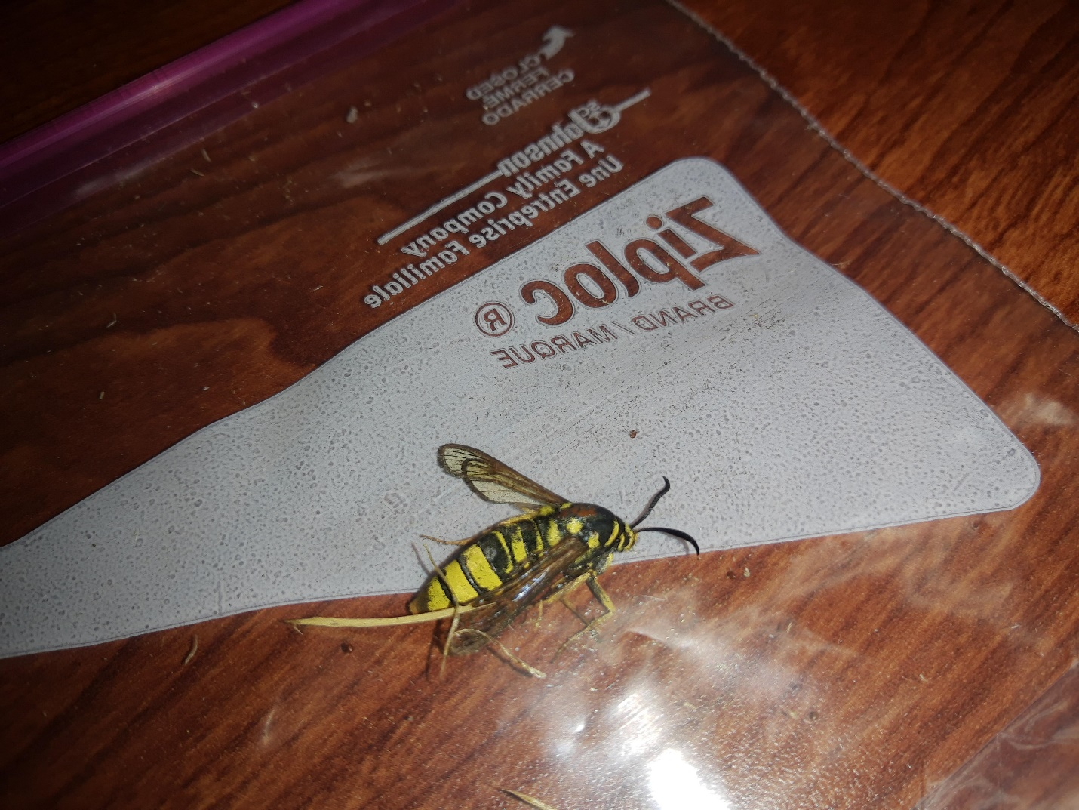

Found at 1890 E Johns Prairie Rd, Shelton WA 98584

Marlene.Smith723@gmail.com